<https://us3.ca.analytics.ibm.com/bi/?perspective=explore&pathRef=.my_folders%2FNew%2Bexploration%2B1&subView=model0000018387a30ef4_00000000>

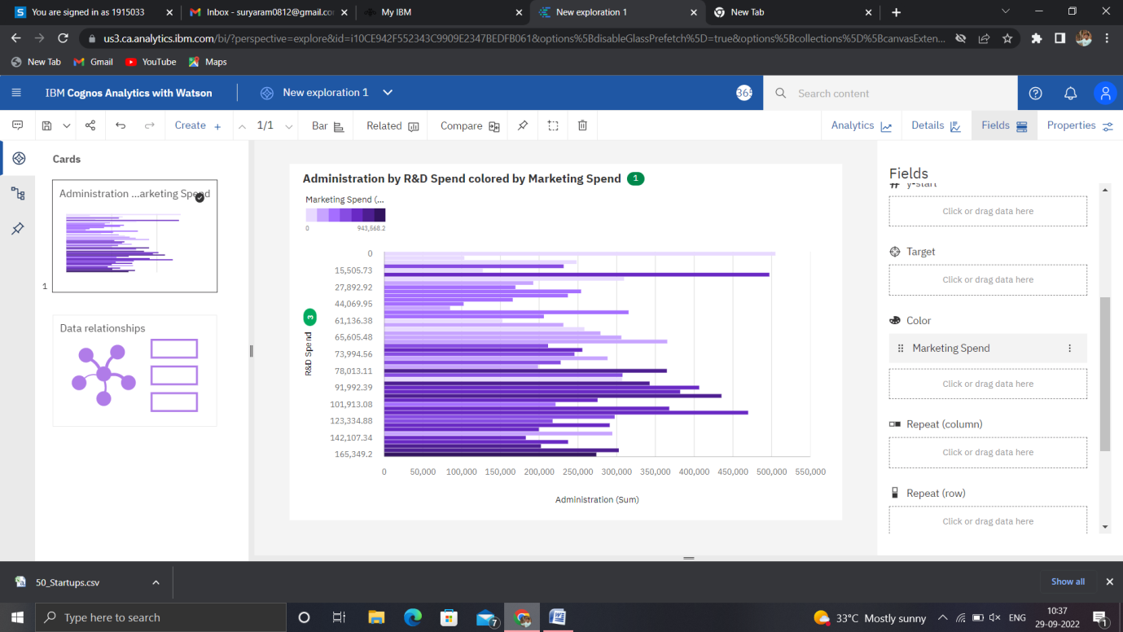

<https://us3.ca.analytics.ibm.com/bi/?perspective=explore&pathRef=.my_folders%2FNew%2Bexploration%2B2&subView=model0000018387a4efc8_00000000>

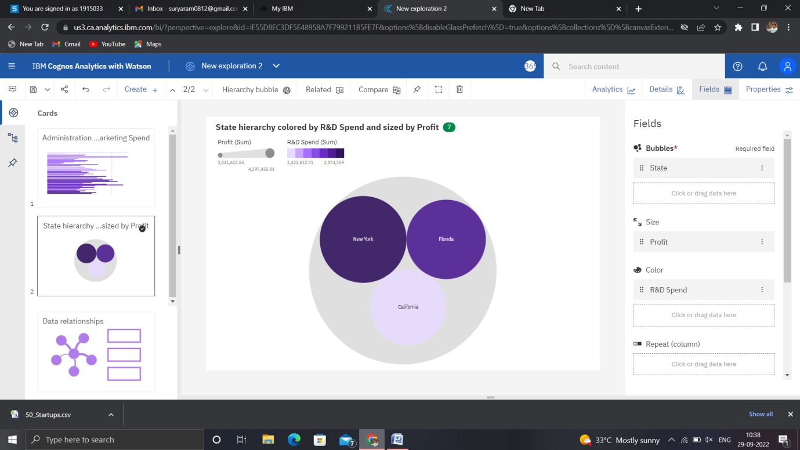

<https://us3.ca.analytics.ibm.com/bi/?perspective=explore&pathRef=.my_folders%2FNew%2Bexploration%2B3&subView=model0000018387a60238_00000000>

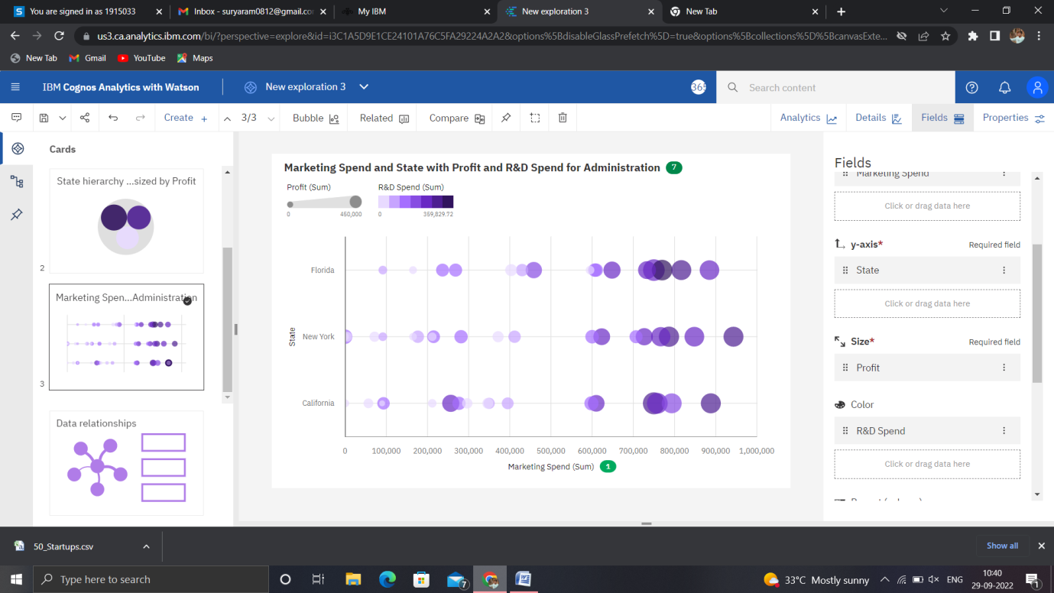

<https://us3.ca.analytics.ibm.com/bi/?perspective=explore&pathRef=.my_folders%2FNew%2Bexploration%2B4&subView=model0000018387a73e99_00000000>

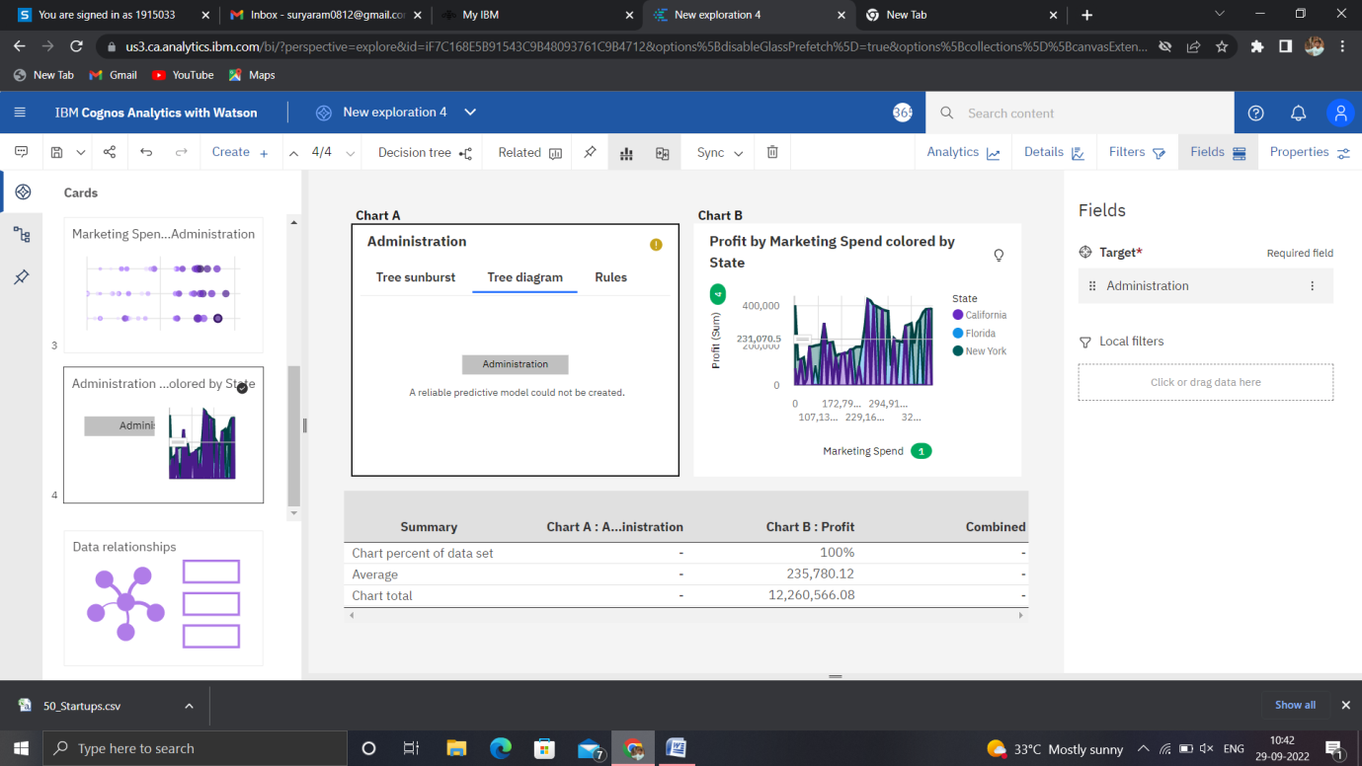

<https://us3.ca.analytics.ibm.com/bi/?perspective=explore&pathRef=.my_folders%2FNew%2Bexploration%2B5&subView=model0000018387ab639e_00000002>

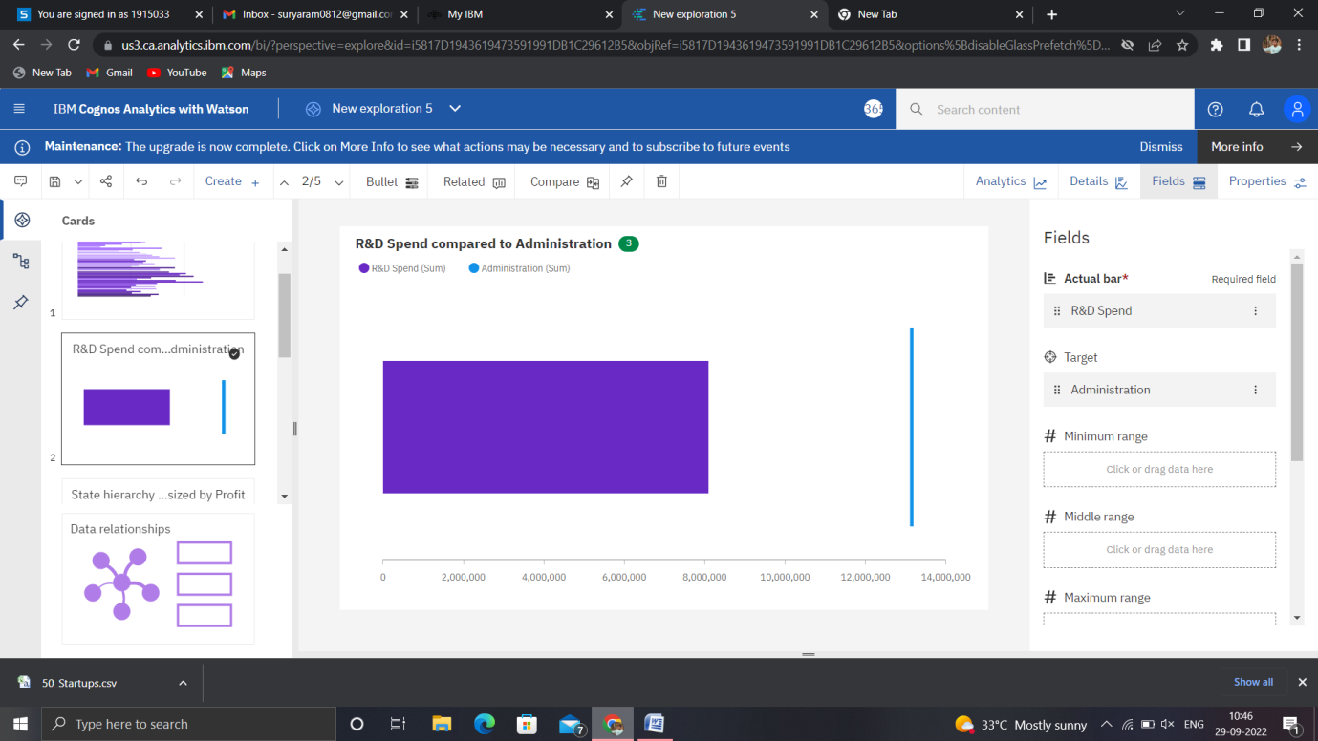

<https://us3.ca.analytics.ibm.com/bi/?perspective=explore&pathRef=.my_folders%2FNew%2Bexploration%2B6&subView=model0000018387acc59e_00000000>

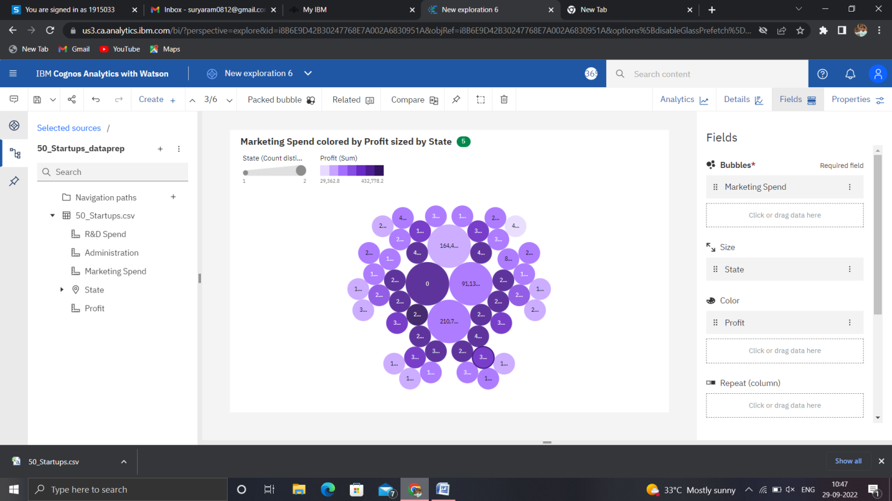

<https://us3.ca.analytics.ibm.com/bi/?perspective=explore&pathRef=.my_folders%2FNew%2Bexploration%2B7&subView=model0000018387adc8f2_00000000>

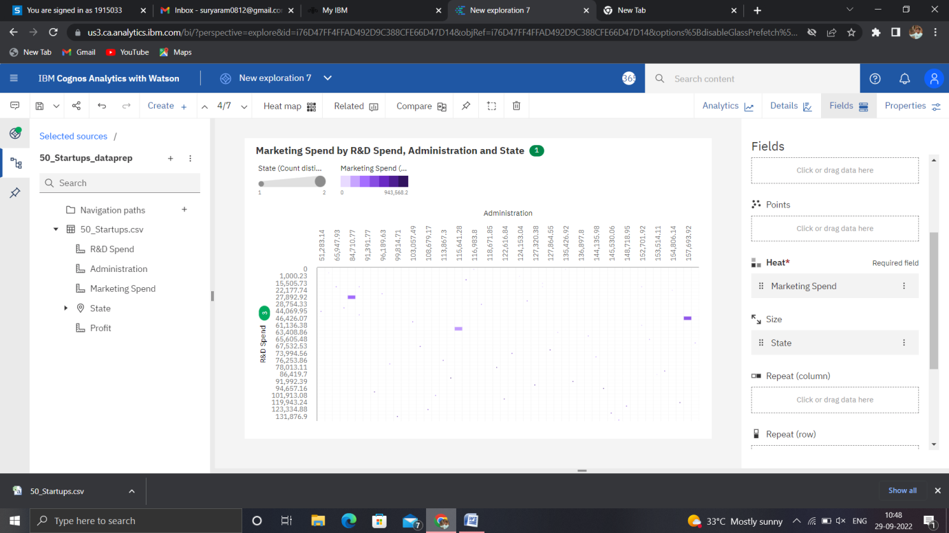

<https://us3.ca.analytics.ibm.com/bi/?perspective=explore&pathRef=.my_folders%2FNew%2Bexploration%2B8&subView=model0000018387aefc92_00000003>

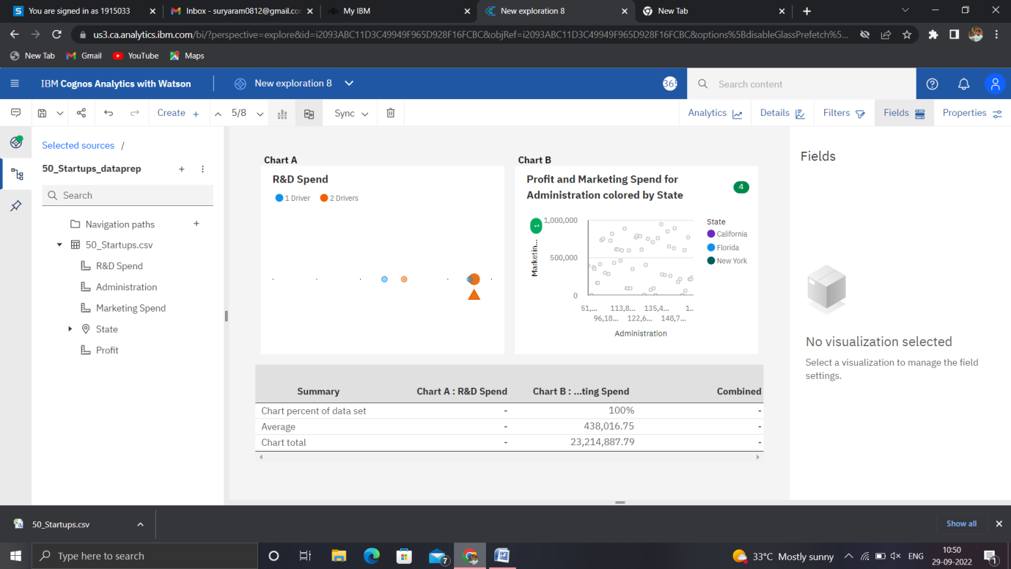

<https://us3.ca.analytics.ibm.com/bi/?perspective=explore&pathRef=.my_folders%2FNew%2Bexploration%2B9&subView=model0000018387b06756_00000004>

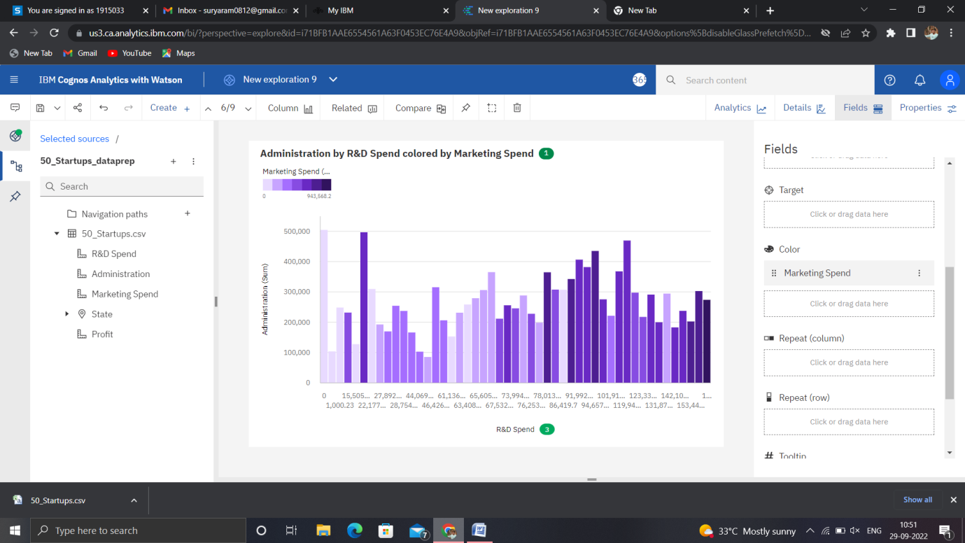

<https://us3.ca.analytics.ibm.com/bi/?perspective=explore&pathRef=.my_folders%2FNew%2Bexploration%2B10&subView=model0000018387b15d06_00000000>

